Do …barbers exist?
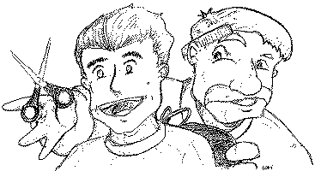
God Does Exist!
A man went to a barbershop to have his hair cut and his beard trimmed. As the barber began to work, they began to have a good conversation. They talked about so many things and various subjects. When they eventually touched on the subject of God, the barber said, “I don’t believe that God exists.” Why do you say that,” asked the customer.
“Well, you just have to go out in the street to realize that God doesn’t exist. Tell me, if God exists, would there be so many sick people? Would there be abandoned children? If God existed there would be neither suffering nor pain. I can’t imagine a loving God who would allow all these things.”
The customer thought for a moment but didn’t respond because He didn’t want to start an argument. The barber finished his job and the customer left the shop. Just as he left the barber shop he saw a man in the street with long, string, dirty hair and an untrimmed beard. He looked dirty and unkept. The customer turned back and entered the barbershop again and he said to the barber, “You know what? Barbers do not exist.”
How can you say that,” asked the surprised barber. “I am here, I am a barber and I just worked on you!” “No!” the customer exclaimed. “Barbers don’t exist because if they did there would be no people with long dirty hair and untrimmed beards like that man outside.” “Ah, but barbers do exists! What happens is people don’t come to me.”
“Exactly,” affirmed the customer. “That’s the point! God, too, does exist! What happens is people do not go to Him or look for Him. That’s why there’s so much pain and suffering in the world.”

