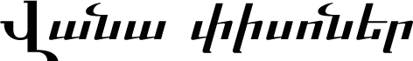
(VAN CAT)
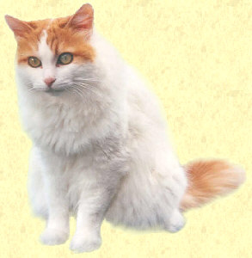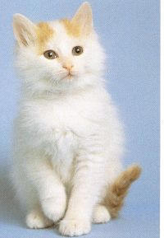
The Van cat is considered a rare breed, one of the most beautiful and certainly the most unusual breeds of a cat ever known. Vans have a long history dating back to the earliest records of Van and ancestral Armenia. They are indigenous to the Van region in the heart of historic Armenia (present day Western Armenia, temporarily occupied by Turkey), particularly to the city of Van, on Vana Lich (Van Lake).
The cat is a natural breed, no human selection or cross-breeding has been used to establish the breed. They are also very unique, the only cats that are known to naturally swim. Vans are a bigger breed then other cats, with predominantly white fur. The Van cat's eyes are always large with eyes of three types: both eyes amber, both eyes blue, or one amber and one blue. Most of the stories about the Van cat seem to be about the blue and amber color eyed cats, perhaps because their eyes seem more expressive.
Its skin is shell-pink, and its ears have long, delicately curved inner tufts, sometimes with 'feathers' on the tips. Van cats can easily be trained, if treated sensibly, and apparently love to be with human beings. The only other colors are an amber tail and amber marks to the head.
Origin
Historic records show the Van cat on cliff-side carvings in the van region from the middle bronze age, especially proliferating in carvings done by Assyria and Urartu, the latter a forebear of the Armenian race. But as with much of what was originally Armenian, the Van cat has been mistakenly mislabeled as Turkish, which is a cause of controversy.
The cat was first exported to the West from present-day Turkey in 1955 by Laura Lushington and Sonia Halliday, two British women who were traveling through Turkey. They noticed that the cats particularly around the area of Van in current occupied Western Armenia bore a remarkable resemblance to the traditional Angora type. The most noticeable difference however was that the coat was not pure white, but had auburn head markings and a faintly ringed auburn tail. Laura brought two unrelated cats back to Britain, and when they were mated they produced kittens bearing the same auburn markings. It was at this point that Laura realized that this was a natural breed, and not man-induced.
When the club set about registering the breed, she registered the Van Cat prefix and added the word "Turkish" to the name, following the example of a Van Cat club in Turkey.
However, carvings and inscriptions found in Assyrian and Urartian records showing the cat as a favored animal or deity predate the Turkish existence in the area by 2000 to 3000 years, causing no end of consternation to present day Turkish historians.
Van cats have been the symbol of Van and the city of Van since at least the middle bronze age, some archeologists believing they developed around the same time as the Armenian Plateau cultivated wheat and livestock, beginning around 14,000 BC. One of the early records of white, semi-long hair cats with ringed tails and colour on their heads were carvings on jewelry by the Hittites (1600-1200 BC), cousins to the Armenian race. The Urartians (1st millennium BC) who settled in the City of Van (Tushpa) carved ringtail cats on ornaments. Archaeological finds in Van province of relics possibly from an ancient battle during the occupation of Armenia by the Romans (AD 75-387), including battle standards and armor bearing images of a large pale self colored cat showing distinctive rings on the cat's tail.
Even more recently, during the excavation by the British Archaeological Institute in Ankara of a late Neolithic (7000 years ago) site near Hacilar, 22 small terracotta statues said to be women playing with cats were found on one level. Because of this discovery some scientists now question the long held belief that cats were first domesticated in Egypt.
Ironically, the Turks now have a special section on their government web site about the cat, recounting that their ancestors called this cat "pisik". Pisik is a pure Armenian root word, meaning "kitten", "piso" being cat. It appears Turks want their ancestors to be Armenian, or perhaps they at least want to admit how much of their culture is due to cultures like Armenia.
Anyway, Van Cats have an international breed name of Turkish Van cat, Turks use the Armenian word 'Pisik', and it is properly called the Van Cat.
About the Van
It is generally assumed that geographic isolation is responsible for the preservation of this unique breed of cat. The most notable feature of the area of Anatolia (present day Western Armenia) is Lake Van in the Bznuniq region of Historic Armenia, bound by the mountains of Suphan (from the original Armenian "Sipan", or "Nekh Masiq" at 4434m a few hundred meters higher then Mt. Aragats, the tallest mountain in the Republic of Armenia at 4097m on the North summit) in the north, and Mt. Nemrut (3046m), in the Taron range to the west of Lake Van (Nemrut is like the Republic's "Arair lehr", with lake at its summit and a mythical origin). There is another Mt. Nemrut (1919m, Armenian " Ashimun Ler") to the south, near Armenia's 1st century BC capital of Tigranakert, also known as the burial place for Armenia's kings.
Source: http://www.tacentral.com/nature/fauna_story.asp?story_no=3
Additional Pictures: http://images.google.com/imgres?imgurl=htt...cial_s%26sa%3DN

